USING THE TEMPLATE [TITLE]

APPLYING THE PK STYLES [SUBTITLE]

Author

Abstract
The abstract must be no overcome the maximum number of characters/words expressed in the Call for Abstract, space included, and formatted with the proper style. Don’t insert any paragraph or sub-paragraph.
In case of citations inside the text (and only if they do not exceed three lines), use the « ... » and the APA notation: «citation» (Author year, page). The same for the (optional) references without citation: use the name of the author between brackets format (Author year) or Author (year) if the name is used in the phrases. Avoid citations exceeding 3 lines. DO NOT use endnotes or footnotes. At the end of the text, insert the bibliography [see after].
Images can be inserted in the desired position directly in the text, using low-res images.
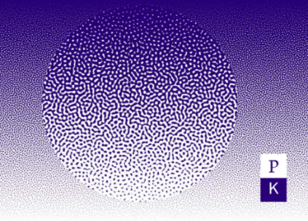
Tables must be converted into images and treated in the same way.

Bibliography
The bibliography should include the most relevant text for the paper. Use APA style (see the website for editorial norms).

Biography
A short biography of no more than 300 character should be included.
Please add your email address: name-surname@example.boh

