USING THE TEMPLATE [TITLE]

APPLYING THE PK STYLES [SUBTITLE]

Author

Title of paragraph (max 100 characters)
The paragraph must be no longer than 300 words and formatted with the proper style. For longer text, please insert a new paragraph. Please for each paragraph, bold-type the most important phrases, limiting them as much as possible: just as this example, the bold phrases does not need to be complete and can be only a part of a longer phrase.
Please avoid as much as possible the use of “;” and “:” in the punctuation, as the longform is primarly aimed to the web version of the journal.
Please do not use subparagraph and do not add numbers to the paragraph.
You can include direct citations in the text. If they exceed 3 lines:
the citation is to be formatted using the proper PK_style. At the end of the citation, don't use a note to indicate the source, but signal only the author following the APA style. (Author year, page)
In case of citations inside the text (and only if they do not exceed three lines), use the « ... » and the APA notation: «citation» (Author year, page). The same for the references without citation: use the name of the author between brackets format (Author year) or Author (year) if the name is used in the phrases. DO NOT use endnotes or footnotes.
Hyperlinks are very welcome: for inserting a hyperlink, just write the link between square parenthesis after the word that will became a hyperlink: e. g. Philosophy Kichen [https://philosophykitchen.com/] is a contemporary philosophy journal.
At the end of the text, insert an annotated bibliography including all cited authors and a overview of relevant sources and references [see after].

Images
Images are to be inserted in the desired position directly in the text, using low-res images. When the longform is accepted, you will have to send the images in high-res format using wetransfer or such services. No captions are allowed, eventual detail of the images are to be included in the text.
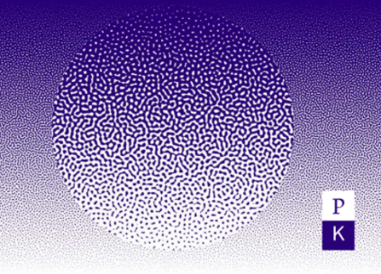
Tables must be converted into images and treated in the same way.

Length of the longform
The whole text, including bibliography, must not exceed 30.000 characters and should be at least 20.000 character. Only in agree with the redaction of Philosophy Kitchen, longer longforms can be accepted. In this case, the text will be published in two separated parts – author should indicate the two parts.
Please mind using the right style for text.

Annotated bibliography
Please write an overview of the most relevant text concerning the field of the longform, suggesting critical issues and important sources. For example: a good starting point for writing a paper could be the text by F. Roncoroni, Manuale di scrittura non creativa (Milano: BUR, 2010) – not to be confused with Manuale di scrittura (non creativa) written by M. Santambrogio (Roma, Bari: Laterza, 2008). These texts either may, or may not, be cited in the longform.
After the annotated bibliography, list ONLY the sources cited in the main text (APA style, see the website for editorial norms). For example, imagine to have cited Roncoroni (2010) in the text: the book by Santambrogio, even if useful in the annotated bibliography, must not be cited in the text list.
Autor(s). (Year). Title. Subtitle. (edition). Place of publication: Publisher.
Calvino, I. (1957). Il barone rampante. Torino: Einaudi.

