[Blanck line]
[Blanck line]
[Blanck line]

USING THE TEMPLATE [TITLE]

APPLYING THE PK STYLES [SUBTITLE]

Author

Short biography of the first author (max 300 characters): The biography must contain essential information. Do not insert any publications or links.
Mail contact
[Blanck line]
Short biography of the second author (max 300 characters): The biography must contain essential information. Do not insert any publications or links.
Mail contact
[Blanck line]
Key Words [3 minimum, 5 maximum]: Esample, example, example, example, example.
[Blanck line]
[Blanck line]
[Blanck line]
Abstract
Write the abstract in English, max 200 words. The abstract must not contain notes or direct citations.
Eventual epigraph. Create a text box (Main toolbar/Insert/Text box). [Stile_PK_epigrafe testo]
Autor date, page [Stile_PK_epigrafe rif.]
[Blanck line]
[Blanck line]
[Blanck line]

Title of paragraph (max 100 characters)
Write the text respecting these indications: font Palatino Linotype, pt. 12; line spacing 1.5; indent first line 0.5. Leave two blank lines before starting the first paragraph or one before the under-paragraph. If in doubt, please see the essays already published on the site.

Citations [eventual subparagraph, max 100 characters]
For the citations in the text: if they exceed 3 lines:
which is to be formatted using the proper PK_style – see comment – or manullay: font Palatino Linotype, pt. 11, line spacing 1, no indentation for first line, but indent left and right by 1 cm. Don't use any « ... » or “...” before and after the text. At the end of the citation, don't use a note to indicate the source, but signal only the author following the APA style. (Author year, page)
In case of citations inside the text (and only if they do not exceed three lines), use the « ... » and the APA notation: «citation» (Author year, page). The same for the references without citation: use the name of the author between brackets format (Author year) and not a note at the end of the page. In the footnote, use the APA citation style and in case of bibliographic references indicate: Author (year).
At the end of the text, insert a bibliography with the cited authors. Every author cited in the text has to be included in the bibliography; at the same time, every author put in the bibliography has to be cited in the text. Please follow the suggested format, verifying the norms of citation for every different publication. Before the bibliography, leave three blank lines.

Images [eventual subparagraph, max 100 characters]
Images must NOT be positioned within the paragraphs. Just put their number between square parentheses as a reference in the text – es. [Fig. 1] – then insert the images IN LOW RESOLUTION after the bibliography and the notes, each with a caption – please see the template.

Tables
For each table, select Table Grid and choose the number of rows and columns you need. Add a reference in the text between square parentheses, like [Tab. 1] and insert the table in the text, with a BLANK LINE before and after it, like in the example below. Adapt the table to the page. Use BOLD font for the title line and, if needed, for the first column. The look of the tables will be formatted afterwards. Under the table, write a caption, see:
[Blanck line]
asdb | ataera | aethaeth
 | asdbasr
 |  | erarh | aerhaerh
Tab. 1. Description, source of data (date). Eventual comments, details or notes.
[Blanck line]
Please mind using the right style for text.

Footnotes. [New Paragraph max 100 characters]
Please DO NOT use the automatic Word insertion. Instead, insert the note number between square brackets in the text. See the example:
Lorem ipsum dolor sit amet, consectetur adipiscing elit, sed do eiusmod tempor incididunt ut labore et dolore magna aliqua. [1] Ut enim ad minim veniam, quis nostrud exercitation ullamco laboris nisi ut aliquip ex ea commodo consequat. [2]
Then, after the bibliography, insert the text of the note preceded by the corresponding progressive number.
[Blanck line]
[Blanck line]
[Blanck line] [ 3 blank lines before bibliography]

Bibliography
Autor(s). (Year). Title. Subtitle. (edition). Place of publication: Publisher.
Calvino, I. (1957). Il barone rampante. Torino: Einaudi.

Notes
[1] As clearly stated by Rossi (2006).
[2] «Aeneadum genetrix, hominum divumque voluptas,. alma Venus, caeli subter labentia signa. quae mare navigerum, quae terras frugiferentis. concelebras» (Lucr. De rerum natura I 1-43)

Images
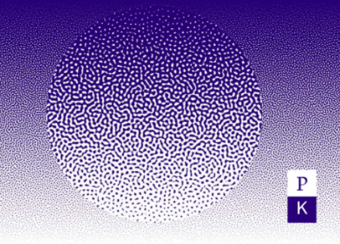
Fig. 1. Philosophy Kitchen 14 (2021). Alea. A detail of the cover of the issue. [the image must be compressed at 96dpi. Image height must be 8cm. For the final paper, hires images at 300dpi will be attached separately]
[Blank line]
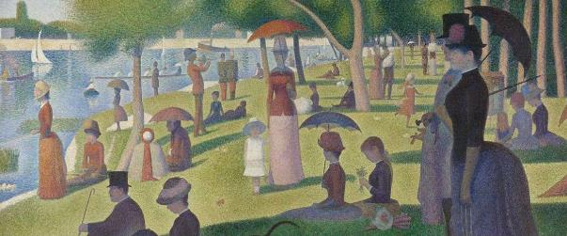
Fig. 2. Georges Seurat, Un dimanche après-midi à l'Île de la Grande Jatte (1883-85). Art Institute of Chicago. [the image must be compressed at 96dpi. Image height must be 8cm. For the final paper, hires images at 300dpi will be attached separately]
[Blank line]
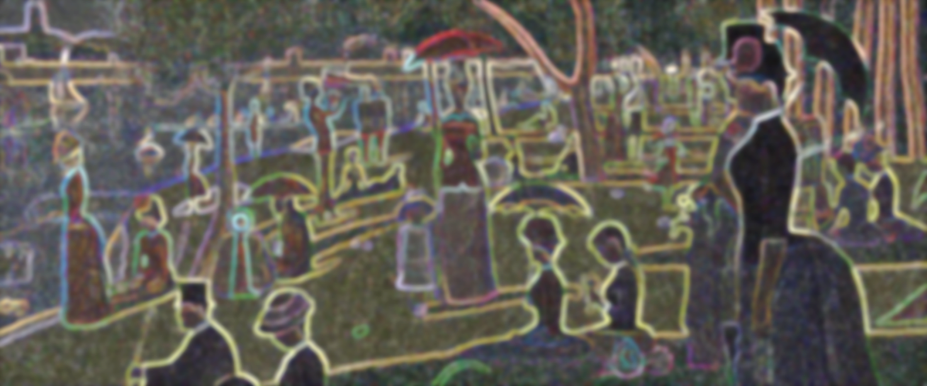
Fig. 2. Author, Title (Date). Eventual comments, details or notes.

PLEASE SEND THE TITLE OF THE ARTICLE AND YOUR BIOGRAPHY TRANSLATED INTO ENGLISH IN A SEPARATE FILE.

